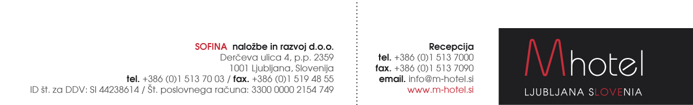

M HOTEL RESERVATION FORM
for the participants of
WORKSHOP ON CAVITATION EXPLOITATION 2023
which will be held in Ljubljana, at the M hotel
20 – 22.9.2023

Reservations to be sent to the following e-mail address: anja.novak@m-hotel.si

First and last name:
Room type and number of persons:
Arrival date:
Departure date:

Special rates:
Single room:  Double/twin room  Tourist tax supplement: | 120,00 EUR / night.  145,00 EUR / night  3,13 EUR / person / night
Limited no. of the rooms are available. Dead-line for the reservations: 26.8.2023

Credit card details
Card name |  |  |  |  |  |  |  |  |  |  |  |  |  |  |  |  |  |  |  |  | Card holder
Card number |  |  |  |  |  |  |  |  |  |  |  |  |  |  |  |  |  |  |  |  | Expiry date
CVC (3 or 4 - digit) |  |  |  |  |  |  |  |  |  |  |  |  |  |  |  |  |  |  |  |  | Signature
Date:
A credit card number and the expiry date are necessary to make and guarantee your booking. Please, return this form by e-mail directly to the hotel: anja.novak@m-hotel.si

Cancellation policy:
In case of cancellation 7 days prior to arrival, cancellation fee will not be charged.
In case of cancellation from 6 to 3 days before arrival, cancellation fee is 50% of the booking value.
In case the booking will not be cancelled till 2 days before the arrival or in case of No-Show, total (100 %) booking value will be charged.

